Output Tree

Lead: John Bez
Developer: Linda O. Jun, Darrel Conway
Tester: John Bez

Requirements
Interface/Functional Spec
Overview
GUI Interface
Test Procedures
Assumptions
Nominal Tests
Output Tree Settings Tests
n/a
Edge/Corner/Miscellaneous Tests
Unique Validation Tests
n/a

Requirements
The requirements are listed below.

Number | Description
FRR-XX.1.0 | The system allows the user at any time after GMAT execution to display Report Files, Ephemeris Files, and Eclipse Locator data. The names referred to match those shown in Figure 3. The system allows the user to minimize, expand and delete the displayed files by using the standard Windows icons in the top right hand corner of the windows.
FRR-XX.1.1 | 1) Display a Report File when ReportFileN is double clicked, where N is the ReportFile number. The Reports can be any name as defined in the Resource Tree.
FRR-XX.1.2 | 2) Display an Ephemeris File when EphemerisFileN is double clicked, where N is the EphemerisFile number. The Ephemeris FIles can be any name as defined in the Resource Tree.
FRR-XX.1.3 | 3) Display an Eclipse Locator when EclipseLocatorN is double clicked, where N is the EclipseLocator number. The Events can be any name as defined in the Resource Tree.
FRR-XX 2.0 | The automatically displays, after GMAT execution, the Orbit Views, the Ground Track Plots, the XY Plots and the Event Data. The plots will be displayed after GMAT is executed, The system allows the user to minimize, expand and delete the plots using the standard Window icons in the upper right hand corner of the plot window.
FRR-XX.2.1 | 1) Display DefaultOrbitView automatically after GMAT execution. The Orbit Views can be any name as defined in the Resource Tree.
FRR-XX.2.2 | 2) Display Ground Track Plots automatically after GMAT execution. The Ground Track Plots can be any name as defined in the Resource Tree.
FRR-XX.2.3 | 3) Display XY Plots automatically after GMAT execution. The XY Plots can be any name as defined in the Resource Tree.
FRR-XX.2.4 | 4) Display Event Data automatically after GMAT execution
FRR-XX.3.0 | The system allows the user to highlight plots by double clicking on:
FRR-XX.3.1 | 1) Orbit Views names, as defined in the Resources tree
FRR-XX.3.2 | 2) Ground Track Plots names, as defined in the Resources Ttree
FRR-XX.3.3 | 3) XY Plots names, as defined in the Resources tree
FRR-XX.4.0 | The system allows Close and Help controls
FRR-XX.4.1 | The system allows the user to Close a displayed ReportFile, EphemerisFile and EclipseLocator file
FRR-XX.4.2 | The system allows the user to request Help on a displayed ReportFile, EphemerisFile and EclipseLocator File. Note that Help was not currently available as of December 2012.
FRR-XX.5.0 | The system allows the user to Select All and Copy ReportFile, EphemerisFile and EclipseLocator file contents to an external file

Interface/Functional Spec

Overview

The Output Tree contains data files and plots after a mission is executed. Files consist of Report Files, Ephemeris Files and Event reports. Plots consist of Orbit Views, Ground Track Plots, XY Plots and Events.

The Output Tree allows the user to display information that the user defines in the Resources Tree Section of GMAT. The user enables the creation of the information by adding instructions in the Mission Tree Section. The information is created at GMAT execution time and is based on the instructions defined in the Mission Tree Section. Once the information is created the user can display the information via the Output Tree. Once the information is displayed the user can Select All and Copy file contents to disk.

GUI Interface

The Figure below shows the default GMAT Window with Output Tree selected:

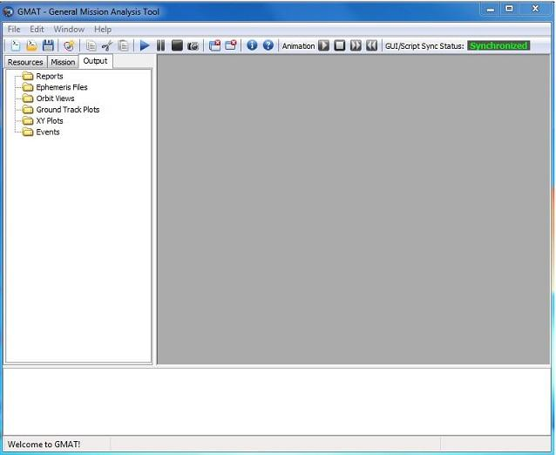

Figure 1: Default GMAT Window showing Output Tree

The Figure below shows the Output Tree portion of the GMAT window:

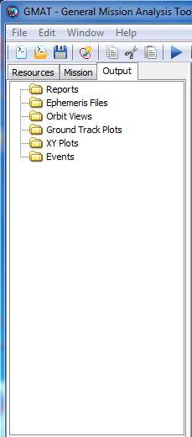

Figure 2: Output Tree portion of GMAT window

The Figure below shows the Output Tree with Orbit View, Ground Track Plot, XY Plot and Event Data displayed. Also 2 Report FIles, an Ephemeris File and an Events File are available for display:

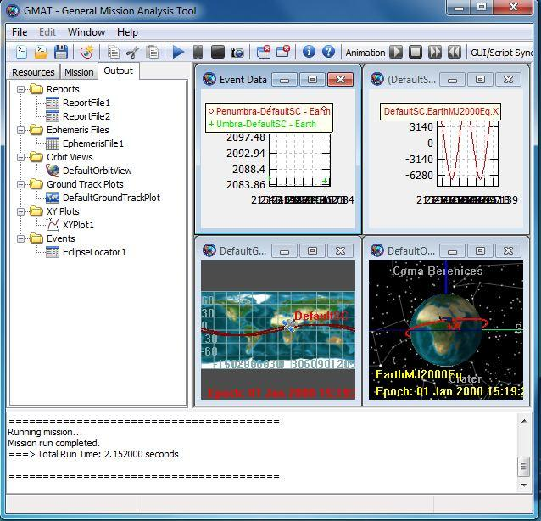
Figure 3: Output Tree showing Orbit View, Ground Track Plot, XY Plot and Event Data

Open Issue: When the user can click in a text box and copy text, we usually have Select All available, and Cntrl-A shortcut selects all text. We don’t have that here which is inconsistent.

Open Issue: Help button is always inactive. Do we remove it of provide a link. I think we should remove the Help link from ReportFile, EphemerisFile, and EventReport

The Figure below shows the Output Tree with a Report File being displayed:

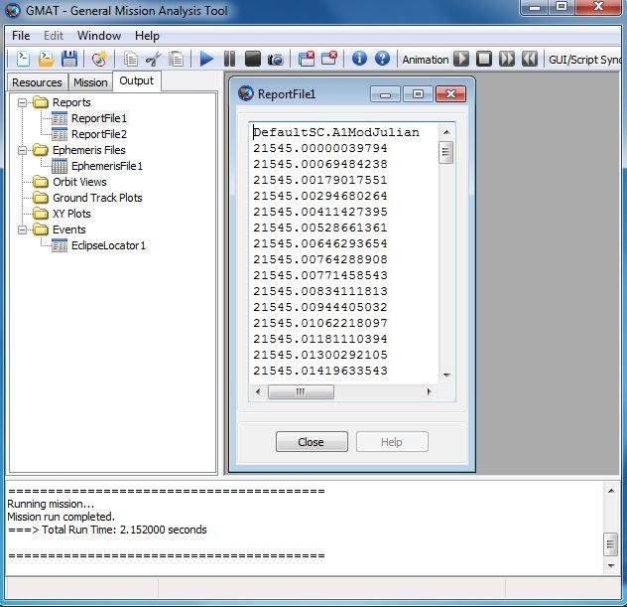
Figure 4: Output Tree showing Report File selected and displayed

The Figure below shows the Output Tree with an Ephemeris File selected :
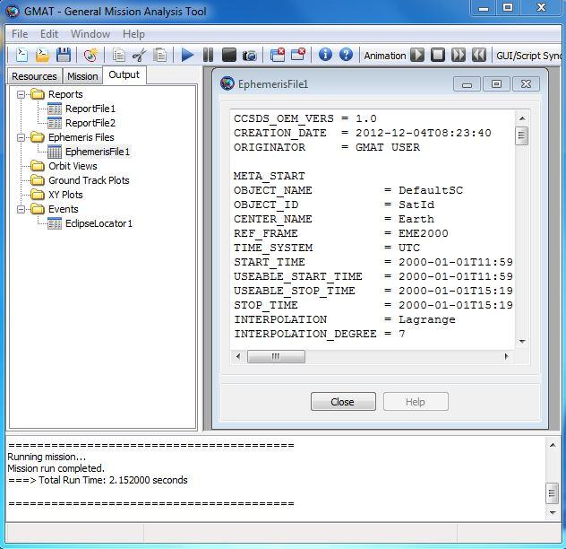
Figure 5: Output Tree with Ephemeris File selected and displayed

The Figure below shows the Output Tree with the Eclipse Locator selected
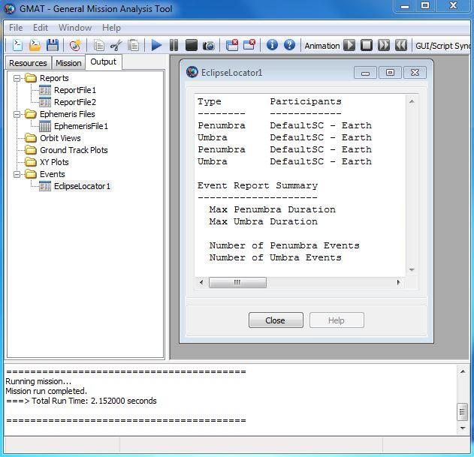
Figure 6: Output Tree with Eclipse Locator selected and displayed

The Figure below shows a ReportFile displayed after a mouse right click. Right clicking on a displayed file brings up the Copy and Select All window.

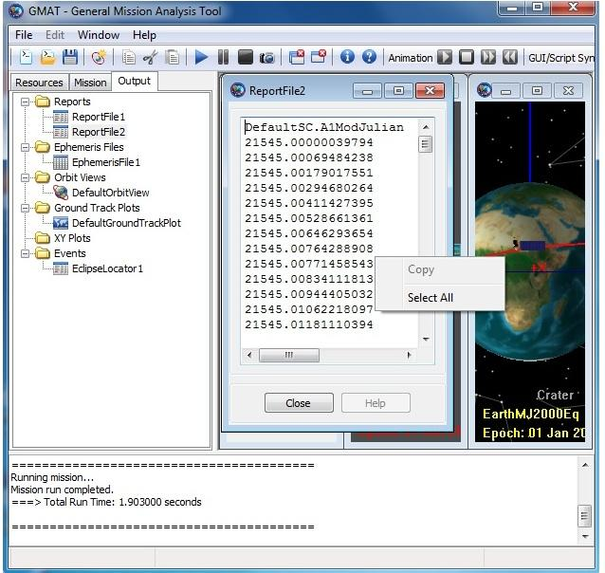
Figure 7. Report File after mouse right click showing Copy and Select All features

Test Procedures

Assumptions
- All tests use the default values

File Naming Conventions
n/a

Nominal Tests

Priority | Status | Summary
P1 | Done  JB | Test whether the system allows displaying of Report Files
P1 | Done  JB | Test whether the system allows displaying of Ephemeris FIles
P1 | Done  JB | Test whether the system allows displaying of Events Files
P1 | Done  JB | Test whether the system allows displaying of Orbit View Plots
P1 | Done  JB | Test whether the system allows displaying of Ground Track Plots
P1 | Done  JB | Test whether the system allows displaying of XY Plots
PI | Done  JB | Test whether the system allows the displaying of Events Plots
P1 | Done for mouse  JB | Test copy and paste from ReportFile window using mouse menu and shortcut keys. Display a Report File, right click and highlight Select All then select Copy. The user can now Paste using other non GMAT programs.
P1 | Done for mouse  JB | Test copy and paste from EphemerisFile window using mouse menu and shortcut keys. Display an EphemerisFile, right click and highlight Select All then select Copy. The user can now Paste using other non GMAT programs.
P1 | Bug 3307 | Test copy and paste from EclipseLocator window using mouse menu and shortcut keys.

